**Academic Honesty Form**

The English Department adheres to the University Policy on Academic Integrity. The following is copied from the NU Manual for Undergraduate Studies (2018):

Dishonesty in the pursuit of knowledge is not acceptable and includes, but is not limited to:

1. Dishonest submission of documents for grade, examples: Plagiarizing reports/cases; cheating on exams or assignments; multiple submissions of the same work for grades; fabrication of data or documents.
2. Obtaining or attempting to obtain an unfair advantage, examples: Gaining access to exams; stealing or destroying library or research materials; unauthorized collaboration on assignments; unauthorized retention or circulation of previous exams; interfering with other students’ work.
3. Unauthorized access to records, examples: Viewing or interfering with confidential computer records or programs or systems, releasing unauthorized information gathered.
4. Aiding and abetting: Providing material, information, or other assistance which violates standards for academic integrity.
5. Threatening, effecting or encouraging bodily, professional, or financial harm to faculty, staff, administrator or student.

Plagiarism in the English courses would be any of the types defined in the table below by Turnitin:

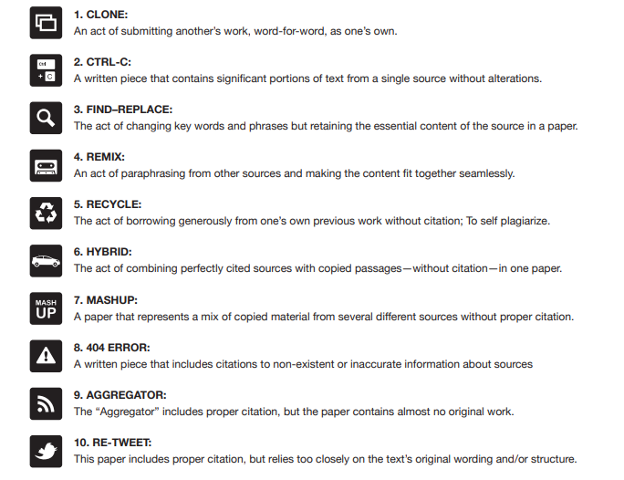

The university reserves the right to take disciplinary action against the violating party(s) according to the principles/procedures shown below:

*An instructor has full authority to deal with an academic dishonesty incident within the context of his/her course. Disciplinary action, in this case, may cover the range from reprimand to “F” for the course grade. The instructor may also recommend suspension or dismissal from the university.*

The instructor's action on incidents of academic dishonesty must be communicated to the student(s) involved; and to the Vice Provost for Student Affairs and the Dean/Program Director within two weeks of the time the instructor became aware of the incident. **All students involved in academic dishonesty will receive an official letter of warning from the Vice Provost for Student Affairs, a copy of which will remain in the students’ file in the department as well as in the Student Affairs Office and/or the provost’s office.**

When a case of academic dishonesty is reported with a recommendation for suspension or dismissal from the Instructor, the Vice Provost of Student Affairs will form an ad-hoc Academic Integrity Committee to investigate the case. The Committee will meet promptly to investigate the case and submit a recommendation to the Vice Provost for Student Affairs, who makes the final decision on the case.

***Academic Integrity and the use of AI:***

The use of AI (e.g, ChatGbt) in submitting assignments depends on the nature of the course and/the assignment. For Intensive A, Intensive B, and English I, there is a no tolerance policy for the use of AI in their assignments since the primary purpose of these courses is to improve their language and sentence structure.

For English II, Writing Skills, and Communication and Presentation Skills, it will be based on the task itself, which will specify how far the students are allowed to use AI in the pre-writing parts.

For all courses, the penalty for using AI outside the boundaries of the task/assignment is the same as the academic honesty policy outlined in the table below. The instructor will detect the use of AI using an AI detector as well as comparing the work to a previous student's writing done in class.

All students should sign the Academic Honesty Form available on Moodle once at the beginning of each semester for all the submitted assignments. The table below shows the possible plagiarism cases and their penalties:

|  |  |
| --- | --- |
| **Case** | **Penalty** |
| 10-25% Plagiarism | Rewrite section(s) + warning |
| Above 25% in chunks | Zero in the draft + warning |
| Copied from a previous course or previously submitted assignment. | Zero in the whole assignment + warning |
| Assignment proven not to be written by the student. | Zero in the whole assignment + warning |
| Assignment copied from another student in a current English Course. | Zero for the two students in the whole assignment + warning |
| Repeated incident of plagiarism | Official notification to Vice Provost of Student Affairs and F in the course |

I fully understand the concept of academic honesty and its consequences as mentioned above. I hereby declare that all the assignments I submit for the course do not violate academic honesty by all means.

|  |  |
| --- | --- |
| **Student Name:ahmed mahmoud ahmed** | **ID:241001013** |
| **Course: english001 intensive** | **Semester:fall2024** |
| **Instructor: dr:aya ashraf** |  |
| **Student’s Signature: ahmed mahmoud** |  |
| **Date: 28/10/2024** |  |